* **How set up backend for ‘terraform.tfstate’ file** (setting up S3 as backend)
  + Create a S3 bucket



* + Ensure that terraform must have following IAM permissions
    - S3:ListBucket
    - S3:GetObject
    - S3:PutObject
  + Now add the following code to terraform file

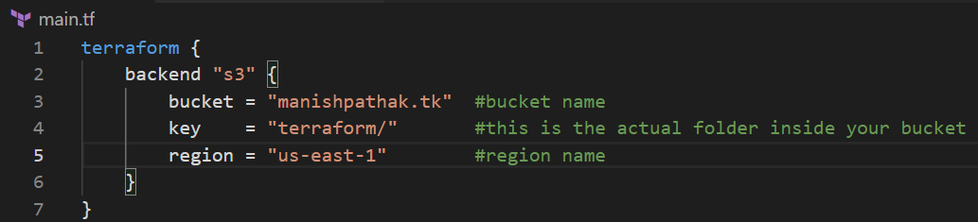

* + Now, do ‘terraform init’. Actually, ‘terraform init’ will look if there is any backend, if there is any, it will configure that as well.
  + Go to S3 bucket and check.

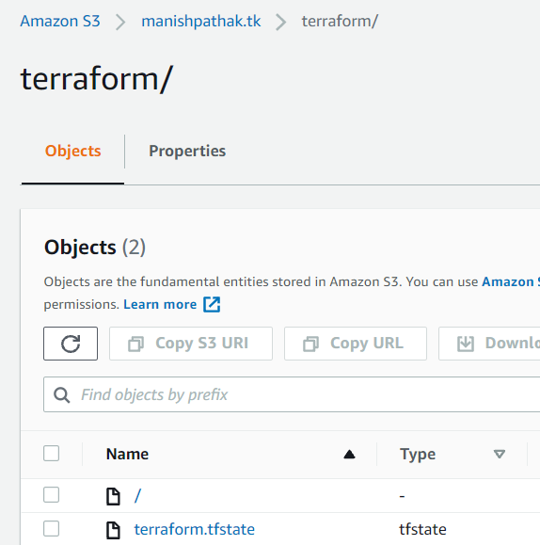

* **How to lock the state file** (terraform.tfstate)
  + but there may be scenarios that more than one person doing the change in same resource at the same time. To sort this out, developer must acquire the lock before making any change.
  + So, locking on S3 backend can be achieved thru Dynamo DB table.
  + Create the DynamoDB table with like following details

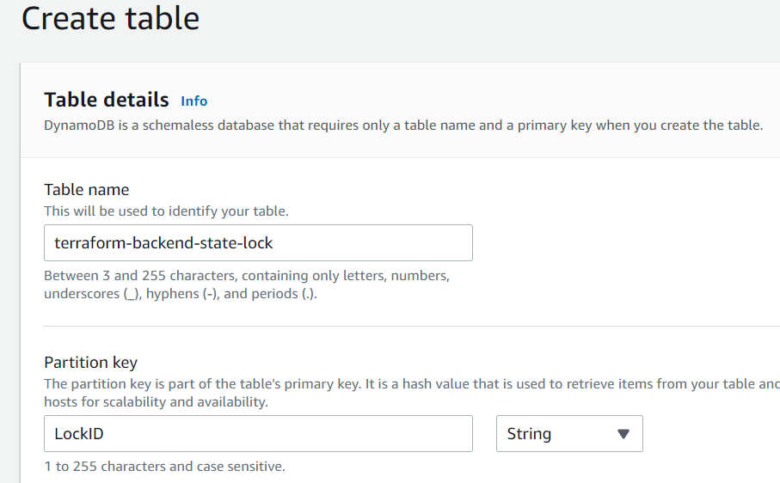

* + Update the backend code to include the dynamodb table like below

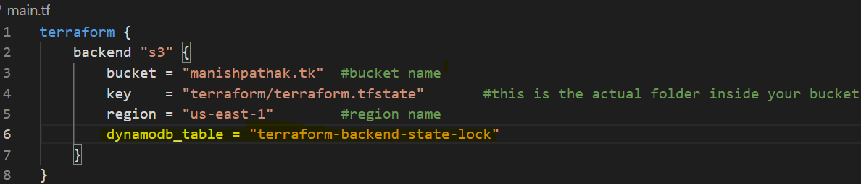

* + Initialize the terraform again with re-configure.



* + Notice for ‘acquiring lock’

